**2D FEM with Boundary Conditions**

*Authors: Adedayo Lawal and Blake Levy*

**Abstract – A two dimensional finite element method (FEM) simulation is presented. An obliquely incident plane wave propagates through an inhomogeneous media backed with a perfect electric conductor (PEC).**

1. **INTRODUCTION**

In various types of computational sciences, the reduction of one spatial dimension can reduce the computational cost. For an obliquely incident plane wave onto an inhomogenous dielectric slab in two-dimensional space, analysis can be performed without any loss of generality in a one-dimensional space. Figure 1 shows the an obliquely incident plane wave on a dielectric space backed by a PEC in two dimensions and its reduction into one dimension respectively.

Figure 1 Left: 2D problem. Right: 1D simplified version

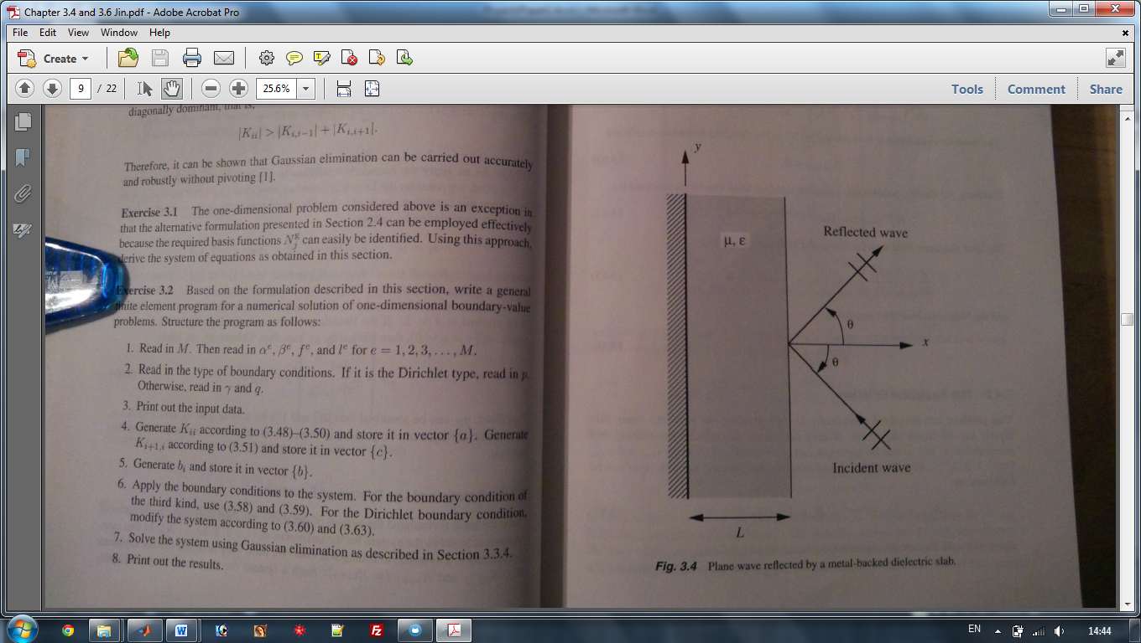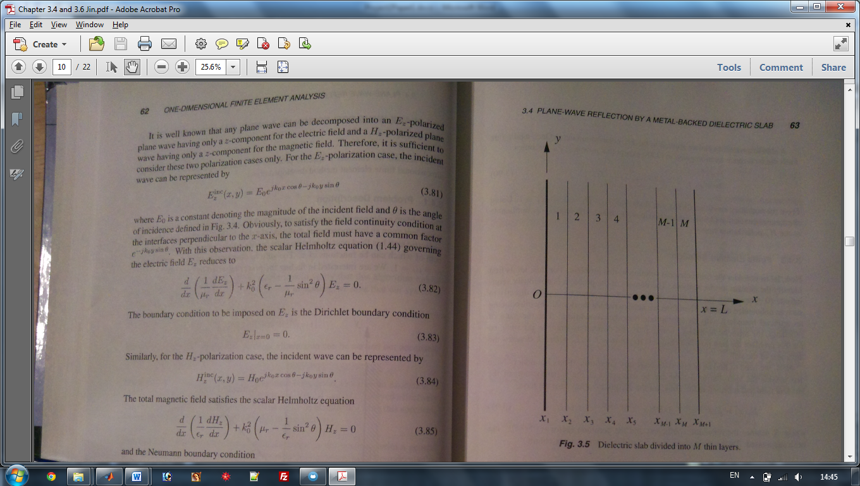

1. **FORMULATION**
   1. **Definition of Parameters**
   2. **Discretization**
   3. **Fundamental Equations**

Fundamental equation: $\frac{∂}{∂x}\left(\frac{1}{μ_{r}}\frac{∂E_{z}}{∂x}\right)+k_{0}^{2}\left(ε_{r}-\frac{1}{μ_{r}}\sin^{2}{θ}\right)E_{z}=0$

Matrix Equations:

and

* 1. **Boundary Condition**

Boundary Conditions:

* 1. **Higher Order Basis Functions**

Figure 4 2D Perfectly Matched Layer (PML)2

1. **RESULTS**
   1. **Error**
   2. **Gaussian Quadrature**
2. **CONCLUSION**
3. **REFERENCES**
4. J. Jin, *The Finite Element Method in Electromagnetics*, 2nd edition, Wiley, 2002.